Chapter 30
Risk Management
30-1. The William Companies (WMB) owns and operates natural gas pipelines that deliver 12% of the natural gas consumed in the United States. WMB is concerned that a major hurricane could disrupt its Gulfstream pipeline, which runs 691 miles through the Gulf of Mexico. In the event of a disruption, the firm anticipates a loss of profits of $65 million. Suppose the likelihood of a disruption is 3% per year, and the beta associated with such a loss is −0.25. If the risk-free interest rate is 5% and the expected return of the market is 10%, what is the actuarially fair insurance premium?
From the SML, the required return for a beta of –0.25 is r_{L} = 5% – 0.25(10% – 5%) = 3.75%. From Eq. 30.1:
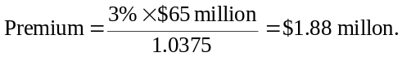
30-2. Genentech’s main facility is located in South San Francisco. Suppose that Genentech would experience a direct loss of $450 million in the event of a major earthquake that disrupted its operations. The chance of such an earthquake is 2% per year, with a beta of −0.5.
a. If the risk-free interest rate is 5% and the expected return of the market is 10%, what is the actuarially fair insurance premium required to cover Genentech’s loss?
b. Suppose the insurance company raises the premium by an additional 15% over the amount calculated in part (a) to cover its administrative and overhead costs. What amount of financial distress or issuance costs would Genentech have to suffer if it were not insured to justify purchasing the insurance?
a. From the SML, the required return for a beta of –0.5 is r_{L} = 5% – 0.5(10% – 5%) = 2.5%. From Eq. 30.1:
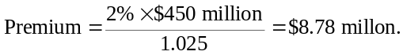
b. With 15% overhead costs, the insurance premium will be $8.78 × (1.15) = $10.098 million. Buying insurance is positive NPV for Genentech if it experiences distress or issuance costs equal to 15% of the amount of the loss. That is, it must experience distress or issuance costs of 15% × 450 = $67.5 million in the event of a loss. In that case:
NPV(buy insurance) = –10.098 + 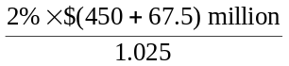 = 0.
30-3. Your firm imports manufactured goods from China. You are worried that U.S.–China trade negotiations could break down next year, leading to a moratorium on imports. In the event of a moratorium, your firm expects its operating profits to decline substantially and its marginal tax rate to fall from its current level of 40% to 10%.
An insurance firm has agreed to write a trade insurance policy that will pay $500,000 in the event of an import moratorium. The chance of a moratorium is estimated to be 10%, with a beta of −1.5. Suppose the risk-free interest rate is 5% and the expected return of the market is 10%.
a. What is the actuarially fair premium for this insurance?
b. What is the NPV of purchasing this insurance for your firm? What is the source of this gain?
a. From the SML, the required return for a beta of –1.5 is r_{L} = 5% – 1.5(10% – 5%) = – 2.5%. From Eq. 30.1:
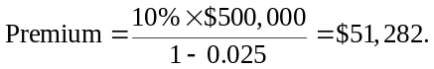
b. If we consider after-tax cash flows:
NPV = – 51,282 × (1 – 0.40) + 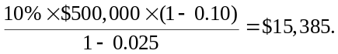
The gain arises because the firm pays for the insurance when its tax rate is high, but receives the insurance payment when its tax rate is low.
30-4. Your firm faces a 9% chance of a potential loss of $10 million next year. If your firm implements new policies, it can reduce the chance of this loss to 4%, but these new policies have an upfront cost of $100,000. Suppose the beta of the loss is 0, and the risk-free interest rate is 5%.
a. If the firm is uninsured, what is the NPV of implementing the new policies?
b. If the firm is fully insured, what is the NPV of implementing the new policies?
c. Given your answer to part (b), what is the actuarially fair cost of full insurance?
d. What is the minimum-size deductible that would leave your firm with an incentive to implement the new policies?
e. What is the actuarially fair price of an insurance policy with the deductible in part (d)?
a. New policies reduce the chance of loss by 9% – 4% = 5%, for an expected savings of 5% × $10 million = $500,000. Therefore, the NPV is
NPV = – 100,000 + 500,000/1.05 = $376,190.
b. If the firm is fully insured, then it will not experience a loss. Thus, there is no benefit to the firm from the new policies. Therefore, NPV = –100,000.
c. If the firm insures fully, it will not have an incentive to implement the new safety policies. Therefore, the insurance company will expected a 9% chance of loss. Therefore, the actuarially fair premium would be
Premium = 9% × $10 million/1.05 = $857,143.
d. If the insurance policy has a deductible, then the firm will benefit from the new policies because it will avoid a loss, and therefore avoid paying the deductible, 5% of the time. Let D be the amount of the deductible. Then the NPV of the new policies is NPV = –100,000 + 5%(D)/1.05.
Setting the NPV to 0 and solving for D we get D = $2.1 million.
e. With a deductible of 2.1 million, the insurance company can expect the firm to implement the new policies. Therefore, it can expect a 4% chance of loss. In the event of a loss, the insurance will pay (10 – 2.1) = $7.9 million. Therefore:
Premium = 4% × $7.9 million/1.05 = $300,952.
Aside: With this policy, the firm will pay $300,952 for insurance, $100,000 to implement the new policies, and 4% × $2.1 million = $84,000 in expected deductibles. Thus, the firm will pay $300,952 + 100,000 + 84,000 = $484,952 in total, which is much less than the amount it would pay for full insurance in (c).
30-5. BHP Billiton is the world’s largest mining firm. BHP expects to produce 2 billion pounds of copper next year, with a production cost of $0.90 per pound.
a. What will be BHP’s operating profit from copper next year if the price of copper is $1.25, $1.50, or $1.75 per pound, and the firm plans to sell all of its copper next year at the going price?
b. What will be BHP’s operating profit from copper next year if the firm enters into a contract to supply copper to end users at an average price of $1.45 per pound?
c. What will be BHP’s operating profit from copper next year if copper prices are described as in part (a), and the firm enters into supply contracts as in part (b) for only 50% of its total output?
d. Describe situations for which each of the strategies in parts (a), (b), and (c) might be optimal.
a. Operating profit = 2 billion pounds × (Price per pound – $0.90/lb). Thus:
b. In this case, they will sell for the contract price of $1.45/lb, no matter what the spot price of copper is next year:
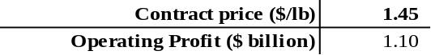
That is, Operating Profit = 2 × (1.45 – 0.90) = $1.10 billion.
c. In this case, Operating Profit = 1 × (1.45 – 0.90) + 1 × (Price – 0.90). Therefore:
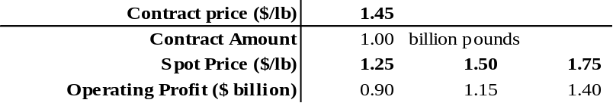
d. Strategy (a) could be optimal if the firm is sufficiently profitable that it will not be distressed even if the copper price next year is low. Equity holders will in this case bear the risk of copper price fluctuations, and there is no gain from hedging the risk. It could also be optimal if the firm is currently in or near financial distress. Then by not hedging, the firm increases its risk. Equity holders can benefit if the price of copper is high, but debt holders suffer if the price is low. (Recall the discussion in Chapter 16 regarding equity holders incentive to increase risk when the firm is in or near financial distress.)
Strategy (b) could be optimal if the firm is not in distress now, but would be if the price of copper next year is low and it does not hedge. Then, by locking in the price it will receive at $1.45/lb, the firm can avoid financial distress costs next year.
Strategy (c) could be optimal if the firm would risk distress with operating profits of $0.7 billion from copper but would not with operating profits of $0.9 billion. In that case, the firm can partially hedge and avoid any risk of financial distress.
30-6. Your utility company will need to buy 100,000 barrels of oil in 10 days time, and it is worried about fuel costs. Suppose you go long 100 oil futures contracts, each for 1000 barrels of oil, at the current futures price of $60 per barrel. Suppose futures prices change each day as follows:

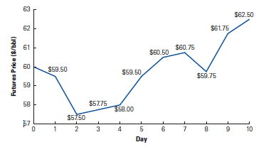
a. What is the mark-to-market profit or loss (in dollars) that you will have on each date?
b. What is your total profit or loss after 10 days? Have you been protected against a rise in oil prices?
c. What is the largest cumulative loss you will experience over the 10-day period? In what case might this be a problem?
a. You have gone long 100 × 1000 = 100,000 barrels of oil. Therefore, the mark-to-market profit or loss will equal 100,000 times the change in the futures price each day.
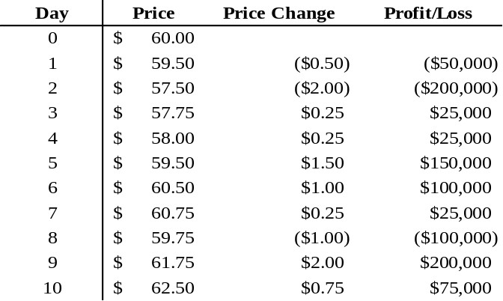
b. Summing the daily profit/loss amounts, the total is a gain of $250,000. This gain offsets your increase in cost from the overall $2.50 increase in oil prices over the 10 days, which increases your total cost of oil by 100,000 × $2.50 = $250,000.
c. After the second day, you have lost a total of $250,000. This loss could be a problem if you do not have sufficient resources to cover the loss. In that case, your position would have been liquidated on day 2, and you would have been stuck with the loss and had to pay the higher cost of oil on day 10.
30-7. Suppose Starbucks consumes 100 million pounds of coffee beans per year. As the price of coffee rises, Starbucks expects to pass along 60% of the cost to its customers through higher prices per cup of coffee. To hedge its profits from fluctuations in coffee prices, Starbucks should lock in the price of how many pounds of coffee beans using supply contracts?
If the price of coffee goes up by $0.01 per pound, Starbucks’ cost of coffee will go up by $0.01 × 100 million = $1 million. But because it can charge higher prices, its revenues will go up by 60% × $1 million = $0.6 million. To hedge this risk, Starbucks should lock in the price for 40 million pounds of coffee, so that it will only suffer an increase in cost for the remaining 60 million pounds of coffee.
30-8. Your start-up company has negotiated a contract to provide a database installation for a manufacturing company in Poland. That firm has agreed to pay you $100,000 in three months time when the installation will occur. However, it insists on paying in Polish zloty (PLN). You don’t want to lose the deal (the company is your first client!), but are worried about the exchange rate risk. In particular, you are worried the zloty could depreciate relative to the dollar. You contact Fortis Bank in Poland to see if you can lock in an exchange rate for the zloty in advance.
a. You find the following table posted on the bank’s Web site, showing zloty per dollar, per euro, and per British pound:
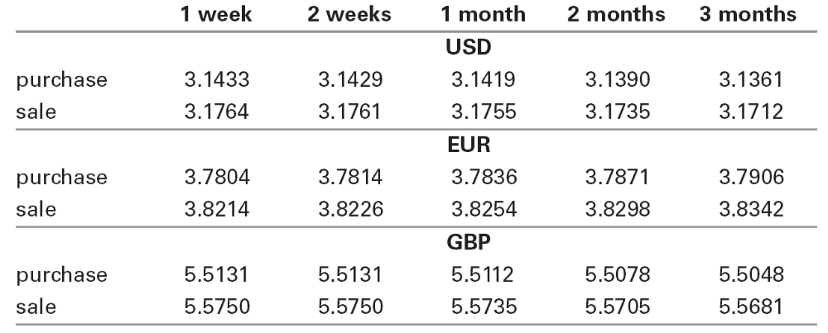
What exchange rate could you lock in for the zloty in three months? How many zloty should you demand in the contract to receive $100,000?
b. Given the bank forward rates in part (a), were short-term interest rates higher or lower in Poland than in the United States at the time? How did Polish rates compare to euro or pound rates? Explain.
a. Check out the Web site for Fortis Bank (www.fortisbank.com.pl). In the upper left of the page you can choose “English” from the menu, and then “currency exch.” There you will be able to find exchange rates for currency forward contracts. Find the rates that applied on March 3, 2006 at 4:15 p.m. What exchange rate could you lock in for zloty in three months? How many zloty should you demand in the contract in order to receive $100,000?
Here is the table from the Web site, showing zloty per $, per euro, and per British pound:
 | 1 week | 2 weeks | 1 month | 2 months | 3 months
USD
purchase | 3.1433 | 3.1429 | 3.1419 | 3.1390 | 3.1361
sale | 3.1764 | 3.1761 | 3.1755 | 3.1735 | 3.1712
EUR
purchase | 3.7804 | 3.7814 | 3.7836 | 3.7871 | 3.7906
sale | 3.8214 | 3.8226 | 3.8254 | 3.8298 | 3.8342
GBP
purchase | 5.5131 | 5.5131 | 5.5112 | 5.5078 | 5.5048
sale | 5.5750 | 5.5750 | 5.5735 | 5.5705 | 5.5681
Thus, you could lock in an exchange rate of 3.1712 zloty per U.S. dollar in three months time through a forward contract with the bank. (Note that when converting zloty to $, you pay the higher rate.) In order to receive $100,000, you would therefore need to write the contract for 100,000 × 3.1712 = 317,120 zloty.
b. The forward rates show that fewer zloty per $ are needed for longer maturities. From Eq 30.3, in terms of zloty per $,
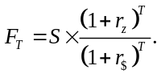
Thus, the zloty interest rate is below the $ interest rate.
In general, from Eq. 30.2, we can tell which rate is higher by seeing if the forward rate is above or below the spot rate. From the table, the forward rates appear to be lower for the British pound, so the pound interest rate was higher at the time of these quotes (March 2006). The euro forward rates are higher than the spot rates, however, suggesting that Polish interest rates were higher than those for the euro.
30-9. You are a broker for frozen seafood products for Choyce Products. You just signed a deal with a Belgian distributor. Under the terms of the contract, in one year you will deliver 4000 kilograms of frozen king crab for 100,000 euros. Your cost for obtaining the king crab is $110,000. All cash flows occur in exactly one year.
a. Plot your profits in one year from the contract as a function of the exchange rate in one year, for exchange rates from $0.75/€ to $1.50/€. Label this line “Unhedged Profits.”
b. Suppose the one-year forward exchange rate is $1.25/€ and that you enter into a forward contract to sell the euros you will receive at this rate. In the figure from part (a), plot your combined profits from the crab contract and the forward contract as a function of the exchange rate in one year. Label this line “Forward Hedge.”
c. Suppose that instead of using a forward contract, you consider using options. A one-year call option to buy euros at a strike price of $1.25/€ is trading for $0.10/€. Similarly a one year put option to sell euros at a strike price of $1.25/€ is trading for $0.10/€. To hedge the risk of your profits, should you buy or sell the call or the put?
d. In the figure from parts (a) and (b), plot your “all in” profits using the option hedge (combined profits of crab contract, option contract, and option price) as a function of the exchange rate in one year. Label this line “Option Hedge.” (Note : You can ignore the effect of interest on the option price.)
e. Suppose that by the end of the year, a trade war erupts, leading to a European embargo on U.S. food products. As a result, your deal is cancelled, and you don’t receive the euros or incur the costs of procuring the crab. However, you still have the profits (or losses) associated with your forward or options contract. In a new figure, plot the profits associated with the forward hedge and the options hedge (labeling each line). When there is a risk of cancellation, which type of hedge has the least downside risk? Explain briefly.
a. Unhedged profit = (100,000 euros) × (S₁ $/euro) – 110,000. See figure below.
b. Forward Hedged profit = (100,000 euros) × (1.25 $/euro) – 110,000 = $15,000. See figure below.
c. You want to sell euros in exchange for dollars. Thus, buying put options will protect the price at which you can sell euros.
d. Buying put options for 100,000 euros costs 100,000 × $0.10 = $10,000.
The put allows you to sell the euros for a minimum of $1.25/euro. Therefore,
All-in Option hedged profit
= (100,000 euros) × (max[1.25,S₁] $/euro) – 110,000 – 10,000
= max[$5,000, (100,000 euros) × (S₁ $/euro) – 120,000].
See figure below.
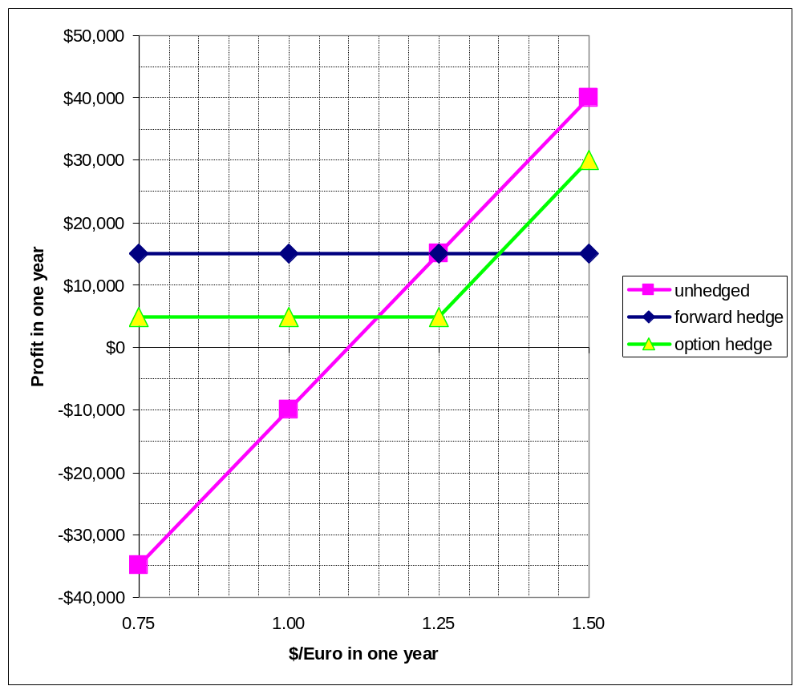
e. For the forward hedge, you receive a payoff from the forward if the value of the euro declines. If the euro appreciates, you have a loss on your forward position. The profit is:
(100,000 euros) × (1.25 – S₁ $/euro).
If the euro appreciates significantly, the loss from the forward hedge can be very large. (See figure below.)
For the option hedge, you receive a payoff from the put if the value of the euro declines. If the euro appreciates, the put is worthless (and are out the original purchase price of the puts). The profit is:
max[0, (100,000 euros) × (1.25 – S₁ $/euro)] – 10,000.
With the puts, the maximum loss is their initial cost of $10,000. (See figure below.)
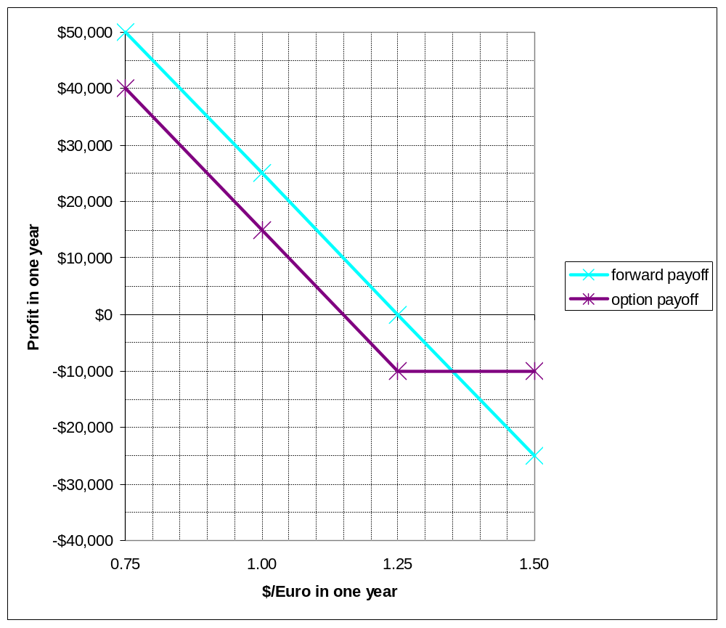
From the picture, an advantage of hedging with options is the limited downside risk in the event of cancellation.
30-10. Suppose the current exchange rate is $1.80/£, the interest rate in the United States is 5.25%, the interest rate in the United Kingdom is 4%, and the volatility of the $/£ exchange rate is 10%. Use the Black-Scholes formula to determine the price of a six-month European call option on the British pound with a strike price of $1.80/£.
The inputs are S = spot exchange rate = 1.80, K = strike price = 1.80, T = 0.5, r$ = 5.25%, r£ = 4.0%, = volatility = 10%. From Eq. 30.3,
F_{T} = S(1 + r$)^{T} / (1 + r£)^{T} = 1.80(1.0525)^{0.5} / (1.04)^{0.5} = $1.8108/£.
Therefore, from Eq. 30.5
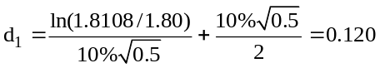, and 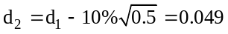
and so N(d₁) = 0.548 and N(d₁) = 0.520.
From Eq. 30.4, C = (1.80 / (1.04)^{0.5}) × (0.548) – (1.80/(1.0525)^{0.5}) × (0.520) = $0.0549
Thus, the call option price is $0.0549/£.
30-11. Assume each of the following securities has the same yield-to-maturity: a five-year, zero-coupon bond; a nine-year, zero-coupon bond; a five-year annuity; and a nine-year annuity. Rank these securities from lowest to highest duration.
The duration of a security is equal to the weighted-average maturity of its cash flows (Eq. 30.6). Thus, the duration of a five-year zero coupon bond is five years, and the duration of the nine-year, zero-coupon bond is nine years (see Ex 30.11).
We cannot determine the durations of the annuities exactly without knowing the current interest rate. But because the cash flows of an annuity are equal and at regular intervals, the duration of an annuity must be less than its average maturity (because weighting by present values will put less weight on later cash flows). Thus, the five-year annuity has a duration of less than (1 + 2 + 3 + 4 + 5) / 5 = 3 years, and the nine-year annuity has a duration of less than (1 + 2 + 3 + 4 + 5 + 6 + 7 + 8 + 9) / 9 = 5 years. The ranking is therefore:
five-year annuity, nine-year annuity, five-year zero, nine-year zero.
30-12. You have been hired as a risk manager for Acorn Savings and Loan. Currently, Acorn’s balance sheet is as follows (in millions of dollars):
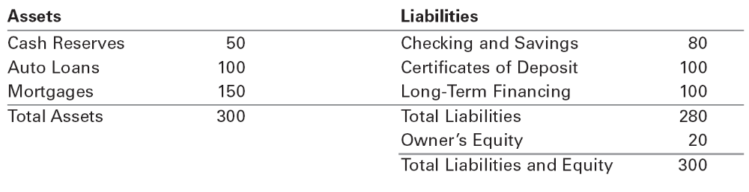
When you analyze the duration of loans, you find that the duration of the auto loans is two years, while the mortgages have a duration of seven years. Both the cash reserves and the checking and savings accounts have a zero duration. The CDs have a duration of two years and the long-term financing has a 10-year duration.
a. What is the duration of Acorn’s equity?
b. Suppose Acorn experiences a rash of mortgage prepayments, reducing the size of the mortgage portfolio from $150 million to $100 million, and increasing cash reserves to $100 million. What is the duration of Acorn’s equity now? If interest rates are currently 4% but fall to 3%, estimate the approximate change in the value of Acorn’s equity.
c. Suppose that after the prepayments in part (b), but before a change in interest rates, Acorn considers managing its risk by selling mortgages and/or buying 10-year Treasury STRIPS (zero-coupon bonds). How many should the firm buy or sell to eliminate its current interest rate risk?
a. From Eq. 30.8,
Asset Duration = 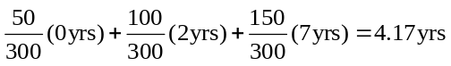
Liability Duration = 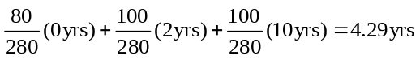
From Eq. 30.9,
Equity Duration = 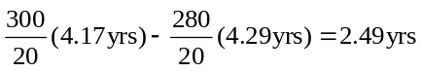
b. Asset Duration = 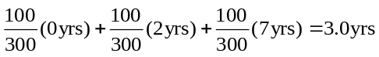
Equity Duration = 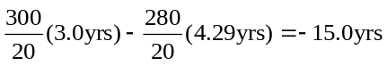
Therefore, if interest rates drop by 1%, we would expect the value of Acorn’s equity to drop by about 15% (or more precisely from Eq. 30.7, 15%/1.04, which equals 14.4%).
c. Acorn would like to increase the duration of its assets, so it should use cash to buy long-term bonds. Because 10-year STRIPS (zero-coupon bonds) have a 10-year duration, we can use Eq. 30.10:
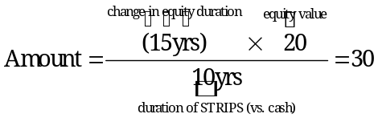
That is, we should buy $30 million worth of 10-year STRIPS.
30-13. The Citrix Fund has invested in a portfolio of government bonds that has a current market value of $44.8 million. The duration of this portfolio of bonds is 13.5 years. The fund has borrowed to purchase these bonds, and the current value of its liabilities (i.e., the current value of the bonds it has issued) is $39.2 million. The duration of these liabilities is four years. The equity in the Citrix Fund (or its net worth) is obviously $5.6 million. The market-value balance sheet below summarizes this information:
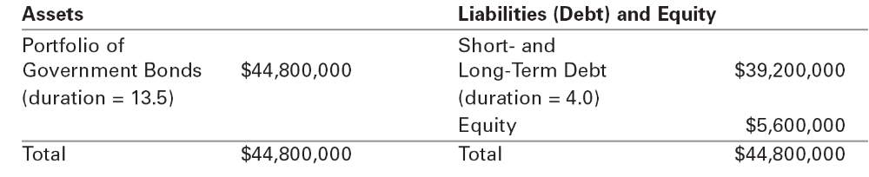
Assume that the current yield curve is flat at 5.5%. You have been hired by the board of directors to evaluate the risk of this fund.
a. Consider the effect of a surprise increase in interest rates, such that the yields rise by 50 basis points (i.e., the yield curve is now flat at 6%). What would happen to the value of the assets in the Citrix Fund? What would happen to the value of the liabilities? What can you conclude about the change in the value of the equity under these conditions?
b. What is the initial duration of the Citrix Fund (i.e., the duration of the equity)?
c. As a result of your analysis, the board of directors fires the current manager of the fund. You are hired and given the objective of minimizing the fund’s exposure to interest rate fluctuations. You are instructed to do so by liquidating a portion of the fund’s assets and reinvesting the proceeds in short-term Treasury bills and notes with an average duration of two years. How many dollars do you need to liquidate and reinvest to minimize the fund’s interest rate sensitivity?
d. Rather than immunizing the fund using the strategy in part (c), you consider using a swap contract. If the duration of a 10-year, fixed-coupon bond is seven years, what is the notational amount of the swap you should enter into? Should you receive or pay the fixed rate portion of the swap?
a. The duration of the assets is 13.5 years. To estimate the effect of a parallel interest-rate of 0.5%, we use the duration formula:
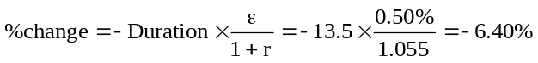,
or a drop in value of 6.40% × $44.8 million = $2.87 million.
Similarly, for the liabilities:
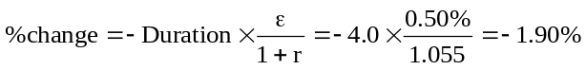,
or a drop in value of 1.90% × $39.2 million = $0.74 million.
As a result, the value of equity will decline by about 2.87 – 0.74 = $2.13 million (a loss of 38% of its value!).
b. From Eq. 30.9:
Equity Duration = 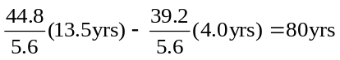
This explains the extreme sensitivity of the equity value to changes in interest rates.
c. Liquidating a portion of the assets and investing in T-bills and notes will reduce the duration of these assets by 13.5 – 2 = 11.5 years. From Eq. 30.10:
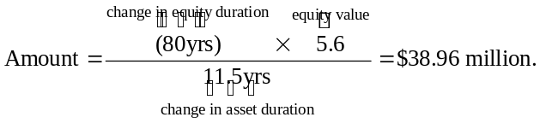
That is, we should liquidate $38.96 million of the fund’s assets.
d. We can also reduce the duration of the fund by entering into a swap contract in which Citrix will receive a floating rate and pay a fixed rate. This swap will increase in value when interest rates rise, offsetting the decline in the value of the rest of the fund. To determine the size of the swap, we proceed as in Ex. 30.14:
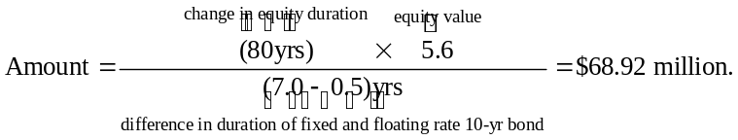
That is, we should enter a swap with a notional value of $68.92 million.
30-14. Your firm needs to raise $100 million in funds. You can borrow short term at a spread of 1% over LIBOR. Alternatively, you can issue 10-year, fixed-rate bonds at a spread of 2.50% over 10-year Treasuries, which currently yield 7.60%. Current 10-year interest rate swaps are quoted at LIBOR versus the 8% fixed rate.
Management believes that the firm is currently “underrated” and that its credit rating is likely to improve in the next year or two. Nevertheless, the managers are not comfortable with the interest rate risk associated with using short-term debt.
a. Suggest a strategy for borrowing the $100 million. What is your effective borrowing rate?
b. Suppose the firm’s credit rating does improve three years later. It can now borrow at a spread of 0.50% over Treasuries, which now yield 9.10% for a seven-year maturity. Also, seven-year interest rate swaps are quoted at LIBOR versus 9.50%. How would you lock in your new credit quality for the next seven years? What is your effective borrowing rate now?
a. Borrow $100m short term and paying LIBOR + 1.0%. Then enter a $100m notional swap to receive LIBOR and pay 8.0% fixed. Effective borrowing rate is (LIBOR + 1.0%) – LIBOR + 8.0% = 9.0%.
(Note: borrowing long-term would have cost 7.6% + 2.5% = 10.1%.)
b. Refinance $100m short-term loan with long-term loan at 9.10% + 0.50% = 9.60%. Unwind swap by entering new swap to pay LIBOR and receive 9.50%. Effective borrowing cost now:
9.60% + (–LIBOR + 8.0%) + (LIBOR – 9.50%) = 8.10%.
(Note: This rate is equal to the original long-term rate, less the 2% decline in the firm’s credit spread. The firm gets the benefit of its improved credit quality without being exposed to the increase in interest rates that occurred.)

